[](http://www.spirovoraion.ru/tinybrowser/fulls/images/novosti/2021/11-02.03.2021.jpg) [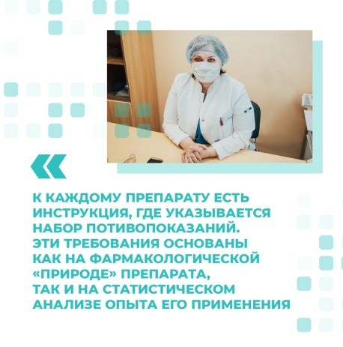](http://www.spirovoraion.ru/tinybrowser/fulls/images/novosti/2021/12-02.03.2021.jpg) [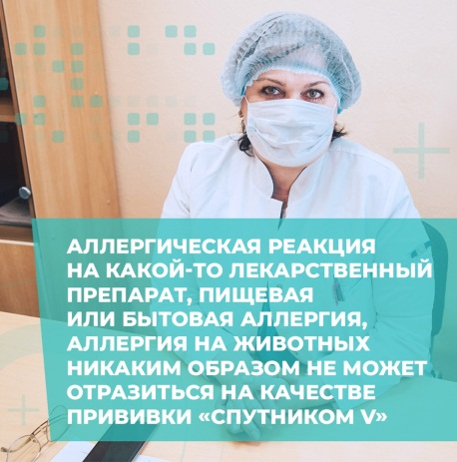](http://www.spirovoraion.ru/tinybrowser/fulls/images/novosti/2021/13-02.03.2021.jpg) [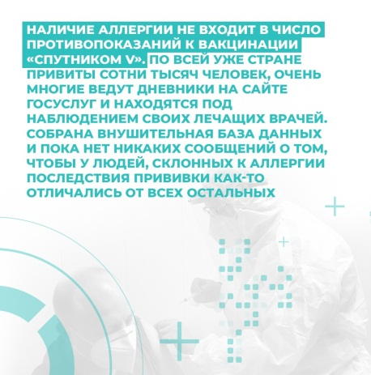](http://www.spirovoraion.ru/tinybrowser/fulls/images/novosti/2021/14-02.03.2021.jpg) [](http://www.spirovoraion.ru/tinybrowser/fulls/images/novosti/2021/15-02.03.2021.jpg) [](http://www.spirovoraion.ru/tinybrowser/fulls/images/novosti/2021/16-02.03.2021.jpg) [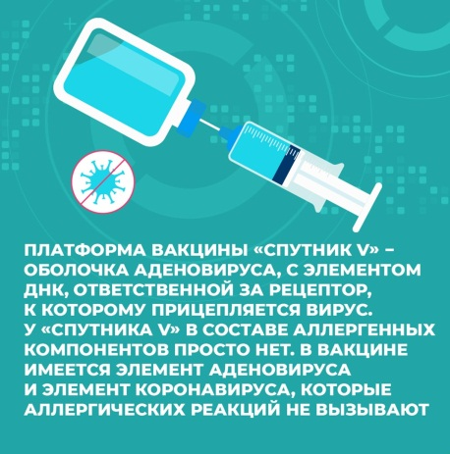](http://www.spirovoraion.ru/tinybrowser/fulls/images/novosti/2021/17-02.03.2021.jpg)